Day 43 – API Fundamentals

What is an API?
API stands for Application Programming Interface.
APIs, or Application Programming Interfaces, are the invisible backbone of modern software development. They enable applications and systems to communicate and share data efficiently.
- Enable seamless interaction between applications, platforms, and services.
- Power everyday features such as weather updates, payments, and e-commerce checkouts.
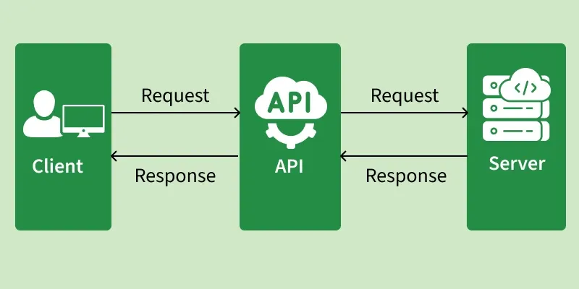

Why Do We Need APIs?
APIs are critical to building scalable, flexible, and connected systems. Here’s why developers rely on them:
- Reusability: Avoid reinventing the wheel by leveraging existing APIs (e.g., Google Maps API, Stripe Payments API).
- Efficiency: Save development time by integrating ready made functionalities.
- Scalability: Enable modular, distributed systems that can grow easily.
- Integration: Connect multiple platforms web, mobile, IoT, or analytics.
- Automation: APIs allow machines to talk to machines without manual input.

How Do APIs Work?
APIs operate through a request response cycle between a client and a server
- Request: The client sends a request to an API endpoint (URI).
- Processing: The API forwards the request to the server.
- Response: The server processes and sends back the requested data.
- Delivery: The API returns the server’s response to the client.
This communication happens over the HTTP/HTTPS protocol, with additional security via headers, tokens, or cookies.

Types of API Architectures

API architectures define how systems communicate and exchange data, each offering different levels of flexibility, performance, and structure based on application needs.

1. REST (Representational State Transfer):
- REST is a simple, flexible API architecture that uses HTTP methods (GET, POST, PUT, DELETE) for communication.
- Data Format: JSON, XML.

2. SOAP (Simple Object Access Protocol):
- SOAP is a more rigid protocol that requires XML based messaging for communication. Strict and secure protocol using XML for structured messaging.
- Data Format: XML

3. GraphQL:
- Modern query language that lets clients fetch only the data they need.
- Data Format: JSON

4. gRPC:
- High performance framework using Protocol Buffers (Protobuf).
- Data Format: Binary

What are REST APIs?

REST stands for Representational State Transfer, and follows the constraints of REST architecture allowing interaction with RESTful web services. It defines a set of functions (GET, PUT, POST, DELETE) that clients use to access server data. The functions used are:
- GET (retrieve a record)
- PUT (update a record)
- POST (create a record)
- DELETE (delete the record)
Its main feature is that REST API is stateless, i.e., the servers do not save clients' data between requests.
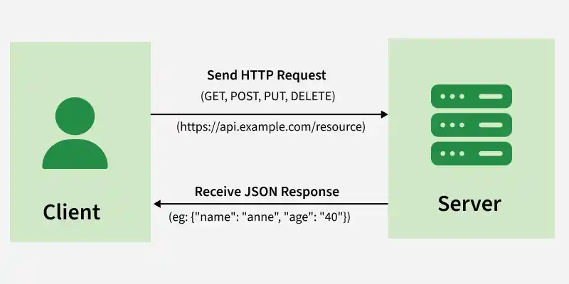

HTTP Status Codes

200 —---------> OK —-------> Request successful.

201 —-----> Created —-------> New resource created.

400 —--> Bad Request —-------> Wrong input provided.

404 —------> Not Found —-------> Requested resource not found.

500 —------> Internal Server Error —----> Problem on server side.

Advantages of APIs
- Efficiency: Enable faster development using reusable components.
- Integration: Seamlessly connect different systems and services.
- Automation: Reduce manual effort by automating workflows.
- Scalability: Simplify distributed and modular system design.
- Innovation: Unlock new functionalities and integrations.

Disadvantages of APIs
- High Cost: Developing and maintaining APIs requires expertise.
- Security Risks: Exposed endpoints can be vulnerable to attacks.
- Versioning Challenges: Managing updates without breaking compatibility.
- Dependency Risk: Relying on third-party APIs introduces failure points.

FastAPI:
FastAPI is a modern and high-performance Python web framework used to build APIs quickly and efficiently. Designed with simplicity it allows developers to create RESTful APIs using Python's type hints which also enable automatic validation and error handling.
One of FastAPI’s key features is its ability to generate interactive API documentation automatically making it easier to test and understand API endpoints. It is an ideal choice for beginners and professionals who want to build fast, secure and scalable web applications with minimal effort.

Features of FastAPI

- Automatic Documentation: FastAPI auto-generates interactive API docs using OpenAPI standard making it easy to test and understand your APIs.
- Python Type Hints: uses type hints to validate inputs and generate docs automatically making code more readable and less error-prone.
- Data Validation: FastAPI uses Pydantic models to validate and serialize/deserialize request data automatically.
- Asynchronous Support: Supports async and await allowing non-blocking code for better performance in I/O-heavy apps.
- Dependency Injection: Built-in support for dependency injection helps keep code modular, testable and clean.
- Built-in Security: Includes OAuth2, JWT and request validation to protect against common security issues.

Installation → pip install fastapi uvicorn
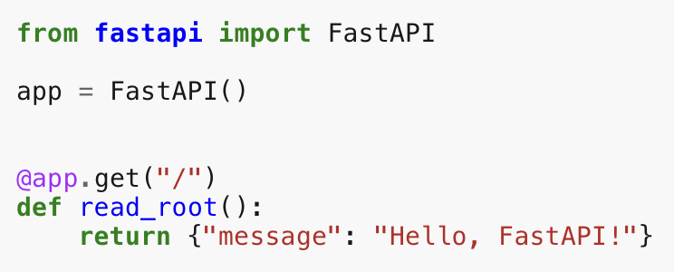

To run the application we need to give →uvicorn app:app --reload

Advantage of FastAPI

- Easy to Learn: Beginner-friendly syntax with automatic docs makes it quick to get started.
- High Performance: Built on async features, it handles many requests efficiently.
- Auto Data Validation: Uses type hints to validate input/output automatically.
- Built-in Auth: Supports JWT, OAuth2 and custom authentication easily.
- Middleware Support: Add logging, auth and more through simple middleware integration.

Disadvantage of FastAPI

- Async Complexity: Requires understanding async/await, which can be tricky for beginners.
- Fewer Built-in Tools: Lacks features like Django’s admin panel, ORM or user auth.
- Smaller Ecosystem: Fewer plugins, tutorials and community support compared to older frameworks.
- Debugging Difficulty: Async debugging is harder than with traditional synchronous code.

